UX Site Audit
Project Name
Digital Corps
Month Year

Overview
Explain what this system is, what the project is.

System Objectives
This information will be gained during stakeholder interviews or client meetings. Get a better understanding of the client’s goals of this system.

Typical Users
Can typically be discovered during client/stakeholder meetings/interviews. Create user personas to have a better understanding of who this system is for and understand the user’s objectives/behavior.

Analytics
Using metrics from sites such as Google Analytics will help provide quantitative data about user behavior, site traffic, user flows, and more.

Heuristic Evaluation
Heuristic | Explanation | Y/N
#1: Visibility of system status | The system should always keep users informed about what is going on, through appropriate feedback within reasonable time.
#2: Match between system and the real world | The system should speak the users' language, with words, phrases and concepts familiar to the user, rather than system-oriented terms.
#3: User control and freedom | Users often choose system functions by mistake and will need a clearly marked "emergency exit" to leave the unwanted state without having to go through an extended dialogue. Support undo and redo.
#4: Consistency and standards | Users should not have to wonder whether different words, situations, or actions mean the same thing.
#5: Error prevention | Even better than good error messages is a careful design which prevents a problem from occurring in the first place.
#6: Recognition rather than recall | Minimize the user's memory load by making objects, actions, and options visible.
#7: Flexibility and efficiency of use | Accelerators may often speed up the interaction for the expert user such that the system can cater to both inexperienced and experienced users.
#8: Aesthetic and minimalist design | Dialogues should not contain information which is irrelevant or rarely needed.
#9: Help users recognize, diagnose, and recover from errors | Error messages should be expressed in plain language (no codes), precisely indicate the problem, and constructively suggest a solution.
#10: Help and documentation | Even though it is better if the system can be used without documentation, it may be necessary to provide help and documentation

Issues Found

Problem 1: Multiple Tabs
Description | When a user does “this” an error message pops up with language not understood by the average user.
Heuristic | #9: Help users recognize, diagnose, and recover from errors
Severity | 1, 2, 3, 4, or 5
Design defect | Explain why this is a design defect - this is the technical portion of what went wrong with the element/feature/section. This can be 1-3 sentences or longer, as needed.
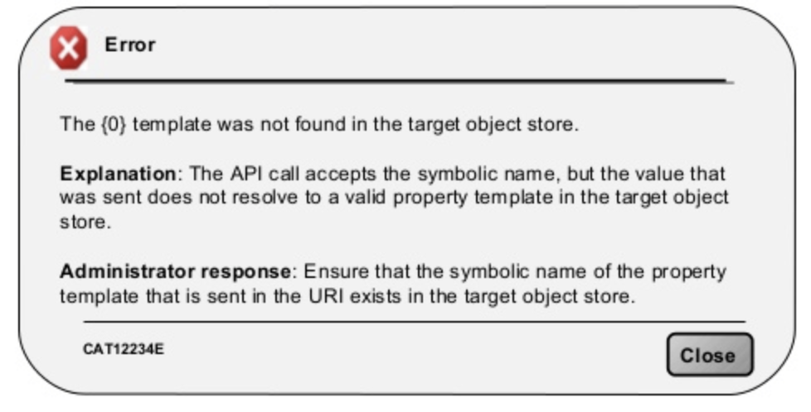
Potential effect on user | Explain how participants feel and how the problem changes their experience in the app/website.
Recommendations for improvement | Explain what should be done to fix the problem.
Link to audio/video example | Include a timestamp of the video/audio recording along with the link

